**WNT Data Sheet**

|  |  |  |  |  |
| --- | --- | --- | --- | --- |
| Customer name | Dongguan DALY Electronics Co., Ltd | | | |
| Customer model | DL-WNT | | | |
| Customer Number |  | | | |
| product model | DL-WNT | | | |
| edition | 1.0 | | | |
| date | 2022-04-15 | | | |
| List of accessories | Item number | Name | Model | Quantity |
| 1 | Motherboard |  | 1 |
| 2 | Motherboard interface Port |  | 1 |
| 3 | NTC line |  | 6 |
| 4 | Communication line |  | 2 |
| 5 | RS485 Upper computer line |  | 1 |
| 6 | BMS Motherboard |  |  |
| 7 |  |  |  |
|  |  |  |  |
|  |  |  |  |

configuration table

|  |  |  |  |
| --- | --- | --- | --- |
| Function | Storage | Non storage of 500 Line storage _____ Line | |
| Display | Non Chinese intelligent English intelligent ______ | |
| Contact | Non Yes | |
| 1. K1 closing condition: closed when there is a fault or protection; (default logic)  2. K2 closing condition: close when there is a low battery alarm; (default logic) | |
| Is there a 120Ω terminal resistor | Non Yes | |
| Weak current switch | Non Yes | |
| Buzzer | Non Yes | |
| Positioning function | Non Yes | |
| Sampling socket | Vertical type Horizontal type | |
| Special Function | 1 |  | |
| 2 |  | |
| 3 |  | |
|  | | | |
| communication | Communication Port | RS232  RS485 Parallel double RS485 UART  Parallel double CAN | |
| Upgrade method | RS232  RS485  CAN | |
| Communication  protocol | DALY standard communication protocol  PYLON CAN protocol  Growatt 485 Protocol  Growatt CAN Protocol  SRNE 485 Protocol  Voltronic Power 485 Protocol  GoodWe CAN Protocol  SOFAR SOLAR 485 Protocol  Schneider CAN Protocol | |

File Change Summary

|  |  |  |  |  |
| --- | --- | --- | --- | --- |
| date | version number | revision note | producer | authorizer |
| 2022-4-15 | 1.0 | Undetermined | Luo Li | Yan lianhong |
|  |  |  |  |  |
|  |  |  |  |  |
|  |  |  |  |  |
|  |  |  |  |  |
|  |  |  |  |  |
|  |  |  |  |  |
|  |  |  |  |  |
|  |  |  |  |  |
|  |  |  |  |  |

**Content**

1. Introduction.......................................................................................................... Page 3
2. Features................................................................................................................ Page 4
3. Functional schematic block diagram.......................................................... Page 4
4. Environmental requirements......................................................................... Page 4
5. LCD description.................................................................................................. Page 5
6. Key description....................................................................................................... Page 6
7. Sleep and wake up............................................................................................ Page 6
8. Communication Description........................................................................... Page 6
9. DIP switch settings............................................................................................ Page 7
10. Interface definition.............................................................................................. Page 7
11. Physical drawing and size drawing.............................................................. Page 9
12. Upper computer description........................................................................... Page 11
13. Parallel system module................................................................................... Page 12

* **Introduction**

## Introduction With the wide application of Lifepo4 battery in the household energy storage industry, high performance, high cost performance and multi-functional requirements are also put forward for the battery management system. This product is a universal interface board specially designed for household energy storage batteries, which can be widely used in household energy storage projects.

* **Features**

|  |  |
| --- | --- |
| ➢ Serial communication function | ➢ Have a variety of sleep and wake up methods |
| ➢ Integrated serial port IC | ➢ Low power consumption |
| ➢ High voltage accuracy (≤20mV) | ➢ Dual RS485 communication |
| ➢ High current accuracy (≤2%@FS) | ➢ Parameter adjustable setting |
| ➢ 4-channel battery temperature detection (≤2℃) | ➢ LED status indication function |
| ➢ SOC estimation function | ➢ Adjustable over current protection |

## Environmental requirements

|  |  |  |
| --- | --- | --- |
| Item | Parameter | Unit |
| Operating temperature | －20～75 | ℃ |
| Storage temperature | －20～75 | ℃ |
| Operating temperature | 10～85 | %RH |
| Storage temperature | 10～85 | %RH |

### LED instructions

Table 1 LED working status indication

|  |  |  |  |  |  |  |  |  |  |  |  |
| --- | --- | --- | --- | --- | --- | --- | --- | --- | --- | --- | --- |
| state | normal/alarm/protect | ON/OFF | RUN | ALM | Battery indicator LED | | | | | | Directions |
| ● | ● | ● | ● | ● | ● | ● | ● | ● |
| shutdown | Hibernate | Off | Off | Off | Off | Off | Off | Off | Off | Off | Annihilate |
| Standby | Normal | on | flash 1 | Off | According to the battery indicator | | | | | | Standby mode |
| Alert | on | flash 1 | flash 3 | Module low voltage |
| Charge | Normal | on | on | Off | According to the battery indicator (battery indication maximum LED flashes 2) | | | | | | The highest power LED flashes (flashing 2), and the ALM does not flash when the overcharge alarm occurs |
| Alert | on | on | flash 3 |
| Over voltage protection | on | on | flash 1 | on | on | on | on | on | on | If there is no utility power, the indicator turns to standby state |
| Temperature, over current, short circuit, reverse connection, fail-safe | on | Off | on | Off | Off | Off | Off | Off | Off | Stop charge |
| Discharge | Normal | on | flash 3 | Off | According to the battery indicator | | | | | |  |
| Alert | on | flash 3 | flash 3 |
| Under voltage protection | on | Off | Off | Off | Off | Off | Off | Off | Off | Stop discharge |
| Temperature, over current, short circuit, reverse connection, fail-safe | on | Off | on | Off | Off | Off | Off | Off | Off | Stop discharge |
| invalid |  | Off | Off | on | Off | Off | Off | Off | Off | Off | Stop charging and discharging |

Table 2 Description of capacity indication

|  |  |  |  |  |  |  |  |  |  |  |  |  |  |
| --- | --- | --- | --- | --- | --- | --- | --- | --- | --- | --- | --- | --- | --- |
| state | |  | Charge | | | | | Discharge | | | | | |
| capacity indicator | | L6● | L5● | L4● | L3● | L2● | L1● | L6● | L5● | L4● | L3● | L2● | L1● |
| SOC（%） | 0～16.6% | Off | Off | Off | Off | Off | flash 2 | Off | Off | Off | Off | Off | on |
| 16.6～33.2% | Off | Off | Off | Off | flash 2 | on | Off | Off | Off | Off | on | on |
| 33.2～49.8% | Off | Off | Off | flash 2 | on | on | Off | Off | Off | on | on | on |
| 49.8～66.4% | Off | Off | flash 2 | on | on | on | Off | Off | on | on | on | on |
| 66.4～83.0% | Off | flash 2 | on | on | on | on | Off | on | on | on | on | on |
| 83.0～100% | flash 2 | on | on | on | on | on | on | on | on | on | on | on |
| Operation indicator● | | on | | | | | | flash (flash 3) | | | | | |

Table 3 LED flashing description

|  |  |  |
| --- | --- | --- |
| flashing method | on | off |
| Flash 1 | 0.25S | 3.75S |
| Flash 2 | 0.5S | 0.5S |
| Flash 3 | 0.5S | 1.5S |

### Button Description

### Hibernate and wake up

**Hibernate**

The interface board itself does not have a sleep function. If the BMS sleeps, the interface board will shut down.

**Wake up**

A single press of the activation button will activate.

## Communication Instructions

### RS232 communication

The RS232 interface can be connected to the upper computer, and the default baud rate is 9600bps.CAN

**CAN communication, RS485 communication**

The default communication rate of CAN is 500K, which can be connected to the upper computer;

The default communication rate of RS485 is 9600, which can be connected to the upper computer;

CAN and RS485 are dual parallel communication interfaces, which support parallel communication of multiple batteries. When CAN is the host, RS485 is used in parallel, and when RS485 is the host, CAN is in parallel. In both cases, you need to flash the corresponding program.

* DIP switch settings

When the PACK’s are used in parallel, different PACK’s can be distinguished by setting the address through the DIP switch on the interface board. It is necessary to avoid setting the same address. Refer to the following table for the definition of the BMS DIP switch.

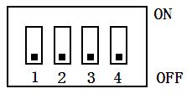

|  |  |  |  |  |
| --- | --- | --- | --- | --- |
| Address | DIP switch position | | | |
|  | #1 | #2 | #3 | #4 |
| 0 | OFF | OFF | OFF | OFF |
| 1 | ON | OFF | OFF | OFF |
| 2 | OFF | ON | OFF | OFF |
| 3 | ON | ON | OFF | OFF |
| 4 | OFF | OFF | ON | OFF |
| 5 | ON | OFF | ON | OFF |
| 6 | OFF | ON | ON | OFF |
| 7 | ON | ON | ON | OFF |
| 8 | OFF | OFF | OFF | ON |
| 9 | ON | OFF | OFF | ON |
| 10 | OFF | ON | OFF | ON |
| 11 | ON | ON | OFF | ON |
| 12 | OFF | OFF | ON | ON |
| 13 | ON | OFF | ON | ON |
| 14 | OFF | ON | ON | ON |
| 15 | ON | ON | ON | ON |

## Interface definition

### Interface diagram

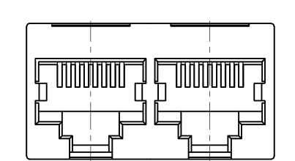 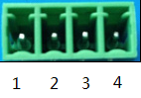

CAN communication port contact

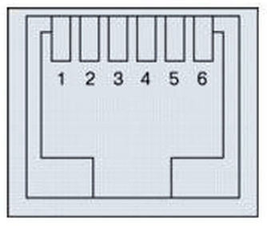

Rs485 communication port RS232 communication interface

|  |  |
| --- | --- |
| RS232--Using 6P6C vertical RJ11 socket | |
| RJ11 pin | Definition Description |
| 2 | NC |
| 3 | TX (single board) |
| 4 | RX(single board) |
| 5 | GND |

|  |  |  |  |
| --- | --- | --- | --- |
| CAN--use 8P8C vertical RJ45 socket | | CAN--use 8P8C vertical RJ45 socket | |
| RJ45:Pin | Definition Description | RJ45引脚 | Definition Description |
| 1、8 | NC | 9 | CANH |
| 2、7 | NC | 10 | CANL |
| 3、6 | GND | 11、14 | GND |
| 4 | CANL | 12 | CANL |
| 5 | CANH | 13 | CANH |
|  |  | 15、16 | NC |

CAN communication port

|  |  |  |  |
| --- | --- | --- | --- |
| RS485--use 8P8C vertical RJ45 socket | | RS485--use 8P8C vertical RJ45 socket | |
| RJ45 Pin | Definition Description | RJ45 Pin | Definition Description |
| 1、8 | RS485-B | 9、16 | RS485-B |
| 2、7 | RS485-A | 10、15 | RS485-A |
| 3、6 | GND | 11、14 | GND |
| 4、5 | NC | 12、13 | NC |

485 communication port

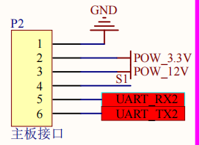 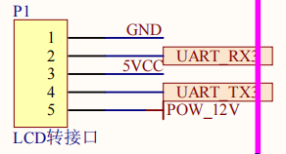

## Physical drawing and size drawing

## Refer to the actual picture: (subject to the actual object)

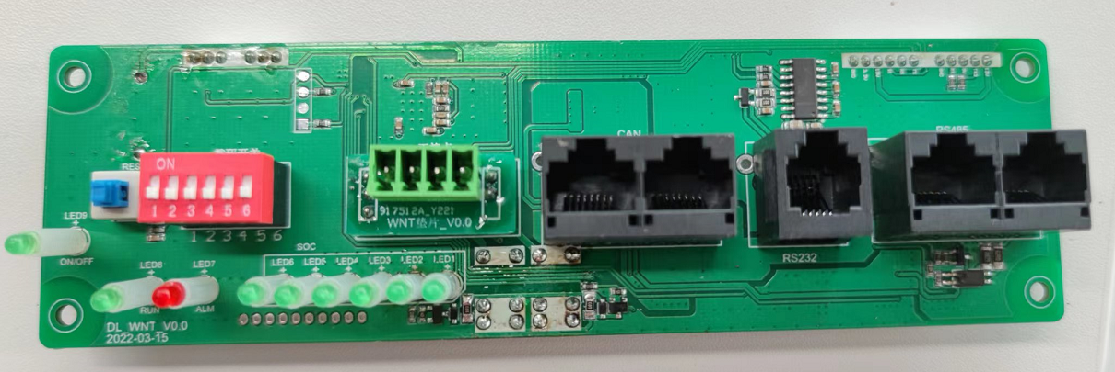

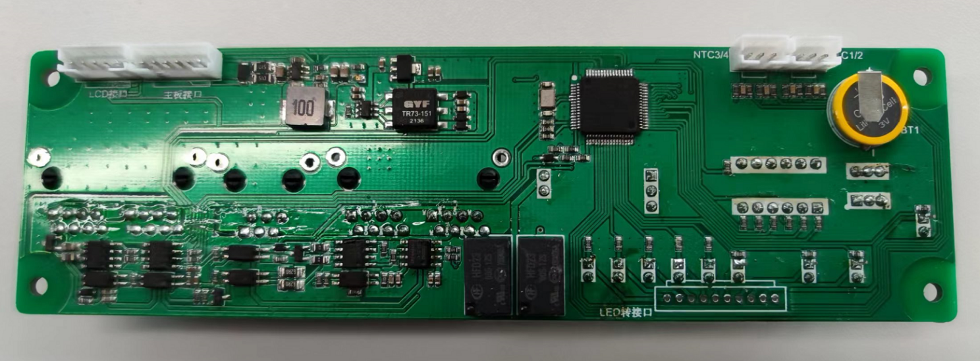

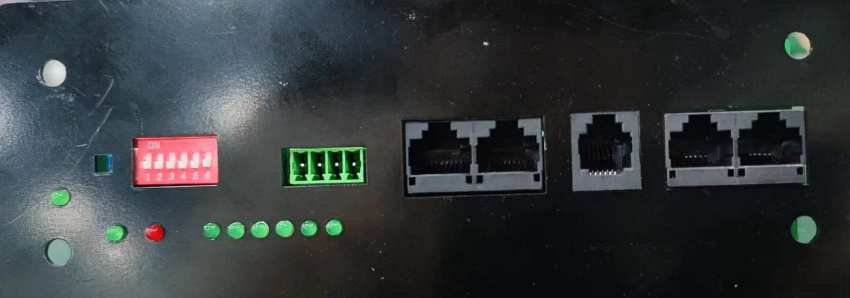

PCB board dimension drawing: (subject to the structure drawing)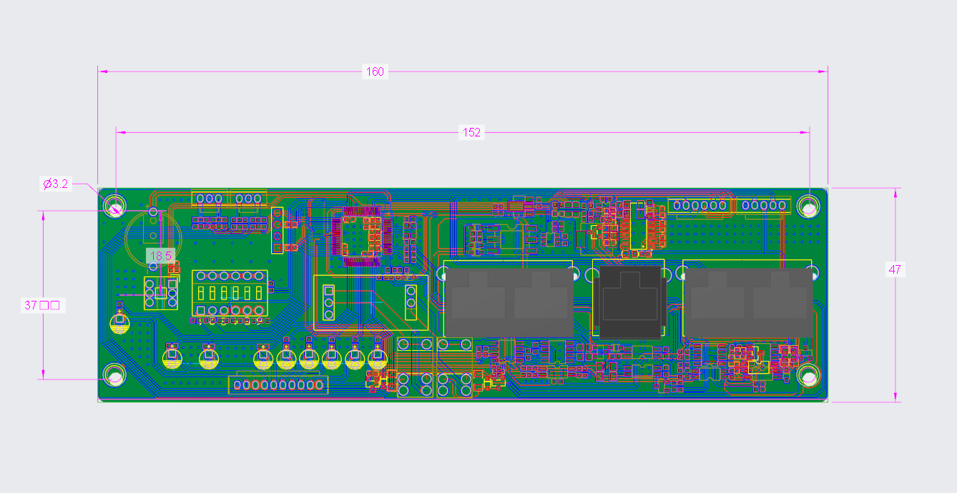

* **Host computer description**

The functions of the host computer V2.1.3 are mainly divided into six parts: data monitoring, parameter setting, parameter reading, engineering mode, historical alarm and BMS upgrade.

1. Analyze the data information sent by each module, and then display the voltage, temperature, configuration value, etc.;

2. Configure information to each module through the host computer;

3. Calibration of production parameters;

4. BMS upgrade.

* **Parallel system module**

A parallel current limiting module specially developed for the PACK parallel connection of the Lithium battery Protection Board. It can limit the large current between PACK due to internal resistance and voltage difference when PACK is parallel connected, effectively ensuring the safety of the cell and the protection plate.

Features